**VIRTUAL STORE PROJECT**

* **SET UP DATABASE**

Oracle Express Edition. Oracle Sql Developer.

* **Table Creation**

Create table script for all tables:

**TYPEOFPRODUCTS:**

CREATE TABLE TYPEOFPRODUCTS

(

PRODUCTIDTYPE int NOT NULL,

PRODUCTTYPE varchar(40) NOT NULL ,

CONSUMPTION int ,

INSTOCK int ,

PRIMARY KEY (PRODUCTIDTYPE)

);

**CUSTOMER:**

CREATE SEQUENCE cid

START WITH 1

INCREMENT BY 1;

create table CUSTOMER(CUSTOMERID INT default cid.nextval, CUSTOMERNAME VARCHAR(70), PHONE VARCHAR(100), primary key(CUSTOMERID));

CREATE SEQUENCE cid

START WITH 1

INCREMENT BY 1;

**PRODUCT:**

CREATE TABLE Product

(

PRODUCTID int NOT NULL,

PRODUCTNAME varchar(50) NOT NULL ,

UNITPRICE number(12,2) NOT NULL ,

PRODUCTIDTYPE int REFERENCES TYPEOFPRODUCTS (PRODUCTIDTYPE),

DESCRIPTION varchar(100),

PRIMARY KEY (PRODUCTID)

);

**ORDERS:**

CREATE SEQUENCE OID

START WITH 1

INCREMENT BY 1;

CREATE TABLE ORDERS

(

ORDERID int default OID.nextvalue,

ORDERNUMBER varchar(10) ,

CUSTOMERID int REFERENCES CUSTOMER (CUSTOMERID) ,

TOTALAMOUNT number(12,2) NOT NULL ,

ORDERDATES TIMESTAMP DEFAULT CURRENT_TIMESTAMP ,

PRIMARY KEY (ORDERID)

);

**ORDERITEM:**

CREATE SEQUENCE OI

START WITH 1

INCREMENT BY 1;

CREATE TABLE ORDERITEM

(

ORDERID int REFERENCES ORDERS(ORDERID),

PRODUCTID int REFERENCES PRODUCT(PRODUCTID),

UNITPRICE number(12,2) NOT NULL ,

QUANTITY int ,

ORDERNUM INT default OI.nextval,

PRIMARY KEY (ORDERID, PRODUCTID,ORDERNUM)

);

**TOTAL OF ORDER USED IN CART (FOODQT):**

Create table FOODQT ( PRODUCTID int REFERENCES PRODUCT(PRODUCTID), ORDERID int REFERENCES ORDERS(ORDERID), TOTALQUANTITY int , UNITPRICE number(12,2), PRIMARY KEY (ORDERID, PRODUCTID));

* **You will have to insert into the product and TYPEOFPRODUCTS table and rest table will be inserted by the website when you click things.**

**INSERTION IN PRODUCT TYPE TABLE:**

Insert into TYPEOFPRODUCTS ( PRODUCTIDTYPE, PRODUCTTYPE, CONSUMPTION, INSTOCK)

Values(1,’FOOD’,2000,3000);

Insert into TYPEOFPRODUCTS ( PRODUCTIDTYPE, PRODUCTTYPE, CONSUMPTION, INSTOCK)

Values(1,’FOOD’,2000,3000);

Insert into TYPEOFPRODUCTS ( PRODUCTIDTYPE, PRODUCTTYPE, CONSUMPTION, INSTOCK)

Values(2,’SPORTS’,400,1000);

Insert into TYPEOFPRODUCTS ( PRODUCTIDTYPE, PRODUCTTYPE, CONSUMPTION, INSTOCK)

Values(3,’ELECTRONICS’,200,300);

**INSERTION IN PRODUCT TABLE:**

Insert into PRODUCT(PRODUCTID, PRODUCTNAME, UNITPRICE, PRODUCTIDTYPE, DESCRIPTION)

Values(1,’ Apple’,2.00,1, ‘Fresh apples straight from the farms of the east. Carefully picked and stored’);

Insert into PRODUCT(PRODUCTID, PRODUCTNAME, UNITPRICE, PRODUCTIDTYPE, DESCRIPTION)

Values(2,’ Tomato’,4.00,1, ‘Ripped Juicy tomatos from the fields. Sensation of this season. Extra good quality!’);

Insert into PRODUCT(PRODUCTID, PRODUCTNAME, UNITPRICE, PRODUCTIDTYPE, DESCRIPTION)

Values(3,’ Beef’,14.00,1, ‘High quality beef from the local slaughterhouse. Recommended by the local authorities. Natural!’);

Insert into PRODUCT(PRODUCTID, PRODUCTNAME, UNITPRICE, PRODUCTIDTYPE, DESCRIPTION)

Values(4,’ Chicken’,13.00,1, ‘From our barns, a locally grown chickens. Fresh quality meat.’);

Insert into PRODUCT(PRODUCTID, PRODUCTNAME, UNITPRICE, PRODUCTIDTYPE, DESCRIPTION)

Values(5,’ Ketchup’,8.35,1, ‘Original Virtual Store ketchup made from homegrown tomatoes. Economical and fresh in taste.’);

Insert into PRODUCT(PRODUCTID, PRODUCTNAME, UNITPRICE, PRODUCTIDTYPE, DESCRIPTION)

Values(6,’ Popcorn’,3.00,1, ‘Lightweight snack for fun times. Low salt added. Hygenic and tastys!’);

Insert into PRODUCT(PRODUCTID, PRODUCTNAME, UNITPRICE, PRODUCTIDTYPE, DESCRIPTION)

Values(7,’ Iphone’,999.00,3, ‘IPhone featuring a 5.8-inch OLED display, facial recognition and 3D camera functionality’);

Insert into PRODUCT(PRODUCTID, PRODUCTNAME, UNITPRICE, PRODUCTIDTYPE, DESCRIPTION)

Values(8,’ROGLAPTOP’,1999.00,3, ‘Ultra-slim gaming laptops yet again with innovative engineering’);

Insert into PRODUCT(PRODUCTID, PRODUCTNAME, UNITPRICE, PRODUCTIDTYPE, DESCRIPTION)

Values(9,’Airdots’,13.00,3, ‘With no wires for a tangle-free experience. The set comes with a charging box’);

Insert into PRODUCT(PRODUCTID, PRODUCTNAME, UNITPRICE, PRODUCTIDTYPE, DESCRIPTION)

Values(10,’ Football’,13.00,2, ‘Soccer ball. Resistant material. High visibility in the field.’);

Insert into PRODUCT(PRODUCTID, PRODUCTNAME, UNITPRICE, PRODUCTIDTYPE, DESCRIPTION)

Values(11,’ Bat’,30.00,2, ‘Short Handle with Top Quality Handle Grip, Thick Blade Cricket Bat.’);

Insert into PRODUCT(PRODUCTID, PRODUCTNAME, UNITPRICE, PRODUCTIDTYPE, DESCRIPTION)

Values(11,’ Ball’,3.00,2, ‘Great ball for recreational players. Superior quality vs. competitor offerings’);

**ERD DIAGRAM**

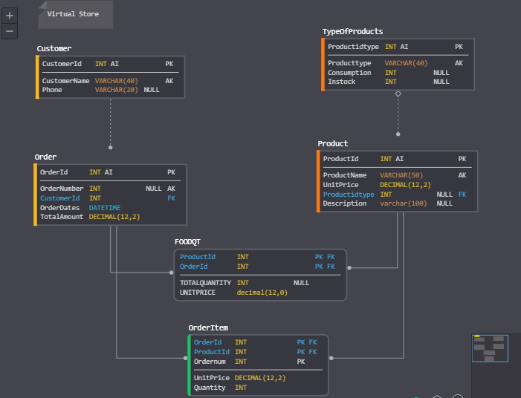

**STEPS TO RUN IT:**

1. **Copy Paste the VirtualStore file in Xampp/htdocs**
2. **Open Xampp controller and connect to Apache and Mysql**
3. **Create all tables in database by running above queries**
4. **Insert the data of 2 tables as done above**
5. **Now go to the following files and change this part of the code to let it connect to your database**

**Use find and replace or go and replace these lines of code manually.**

1. **Addorder.php**

**$conn=oci_connect("SYSTEM","shah123","localhost/XE"); line 5**

Put your username in place of SYSTEM

Your password in name of shah123

Your host in place of localhost

And your service in place of XE

1. **Airdot.php**

**$conn=oci_connect("SYSTEM","shah123","localhost/XE"); line 6**

**Change to your database**

1. **Ball.php**

**$conn=oci_connect("SYSTEM","shah123","localhost/XE"); line 6**

**Change to your database**

1. **Bat.php**

**$conn=oci_connect("SYSTEM","shah123","localhost/XE"); line 6**

**Change to your database**

1. **Beef.php**

**$conn=oci_connect("SYSTEM","shah123","localhost/XE"); line 6**

**Change to your database**

1. **Chicken.php**

**$conn=oci_connect("SYSTEM","shah123","localhost/XE"); line 6**

**Change to your database**

1. **Customer.php**

**$conn=oci_connect("SYSTEM","shah123","localhost/XE"); line 3**

**Change to your database**

1. **Electronicscalculate.php**

**$conn=oci_connect("SYSTEM","shah123","localhost/XE"); line 7**

**Change to your database**

1. **Foodcalculate.php**

**$conn=oci_connect("SYSTEM","shah123","localhost/XE"); line 7**

**Change to your database**

1. **Fooditempick.php**

**$conn=oci_connect("SYSTEM","shah123","localhost/XE"); line 6**

**Change to your database**

1. **Foodlist.php**

**$conn=oci_connect("SYSTEM","shah123","localhost/XE"); line 6**

**Change to your database**

1. **Football.php**

**$conn=oci_connect("SYSTEM","shah123","localhost/XE"); line 6**

**Change to your database**

1. **Iphone.php**

**$conn=oci_connect("SYSTEM","shah123","localhost/XE"); line 6**

**Change to your database**

1. **Ketchup.php**

**$conn=oci_connect("SYSTEM","shah123","localhost/XE"); line 6**

**Change to your database**

1. **Laptop.php**

**$conn=oci_connect("SYSTEM","shah123","localhost/XE"); line 6**

**Change to your database**

1. **Login1.php**

**$conn=oci_connect("SYSTEM","shah123","localhost/XE"); line 10**

**Change to your database**

1. **Popcorn.php**

**$conn=oci_connect("SYSTEM","shah123","localhost/XE"); line 6**

**Change to your database**

1. **All Remove “xyz”.php files**

**$conn=oci_connect("SYSTEM","shah123","localhost/XE"); line 7**

**Change to your database**

1. **Sportscalculate.php**

**$conn=oci_connect("SYSTEM","shah123","localhost/XE"); line 7**

**Change to your database**

1. **Tomato.php**

**$conn=oci_connect("SYSTEM","shah123","localhost/XE"); line 7**

**Change to your database**

1. **Trylist.php**

**$conn=oci_connect("SYSTEM","shah123","localhost/XE"); line 138**

**$conn=oci_connect("SYSTEM","shah123","localhost/XE"); line 238**

**$conn=oci_connect("SYSTEM","shah123","localhost/XE"); line 337**

**$conn=oci_connect("SYSTEM","shah123","localhost/XE"); line 417**

**$conn=oci_connect("SYSTEM","shah123","localhost/XE"); line 496**

**$conn=oci_connect("SYSTEM","shah123","localhost/XE"); line 574**

**$conn=oci_connect("SYSTEM","shah123","localhost/XE"); line 645**

**$conn=oci_connect("SYSTEM","shah123","localhost/XE"); line 706**

**$conn=oci_connect("SYSTEM","shah123","localhost/XE"); line 767**

**$conn=oci_connect("SYSTEM","shah123","localhost/XE"); line 835**

**$conn=oci_connect("SYSTEM","shah123","localhost/XE"); line 896**

**$conn=oci_connect("SYSTEM","shah123","localhost/XE"); line 957**

**$conn=oci_connect("SYSTEM","shah123","localhost/XE"); line 1030**

**Change to your database**

1. **Now you are good to go**
2. **Open browser type 127.0.0.1/VirtualStore**

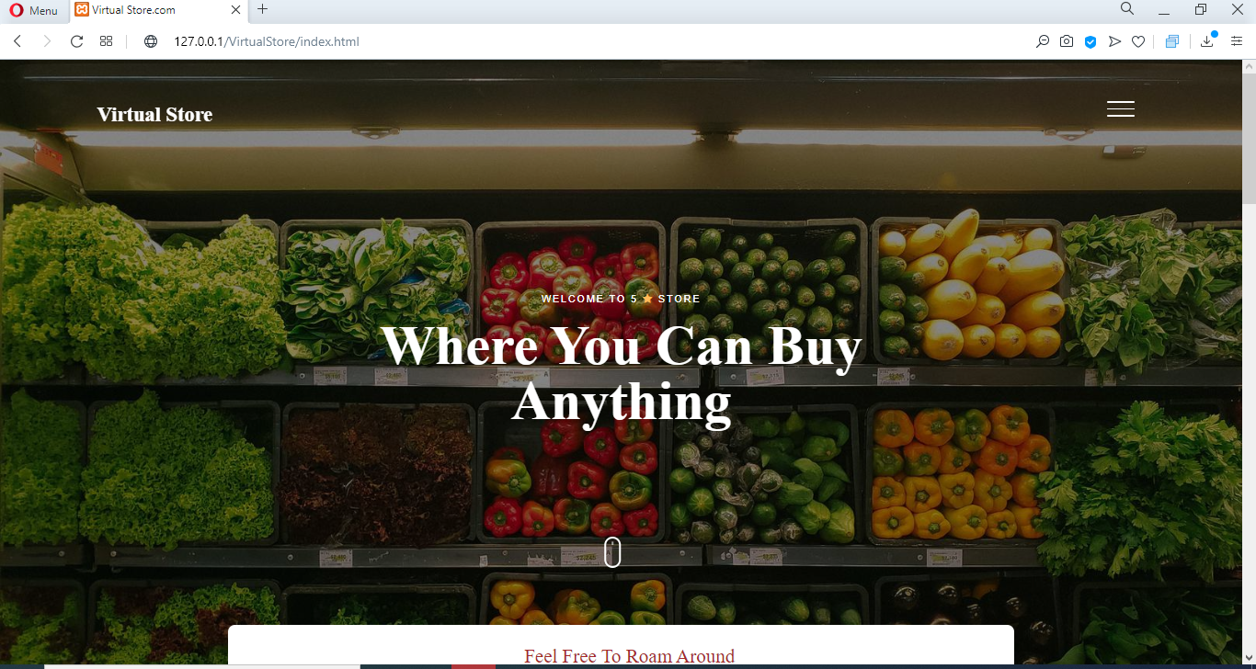

1. **Go to side menu bar on right**

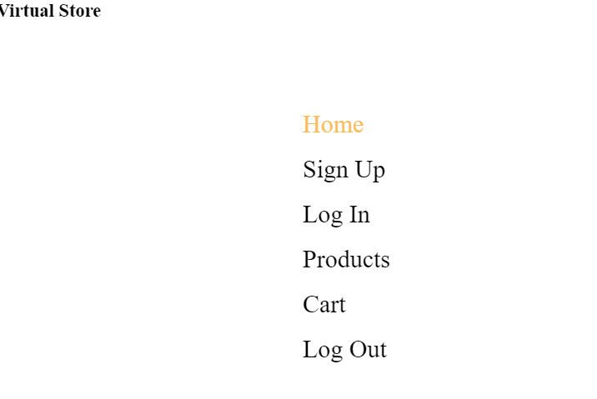

1. **Click Sign Up**

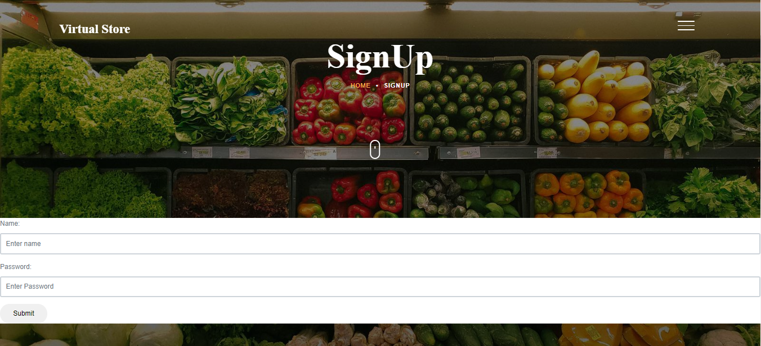

1. **Put in valid name and password and click submit. By doing this customer.php file will run and a customername and phone will be inserted in the database which will be your log in details. If the query runs successfully the page will redirect to log in page**

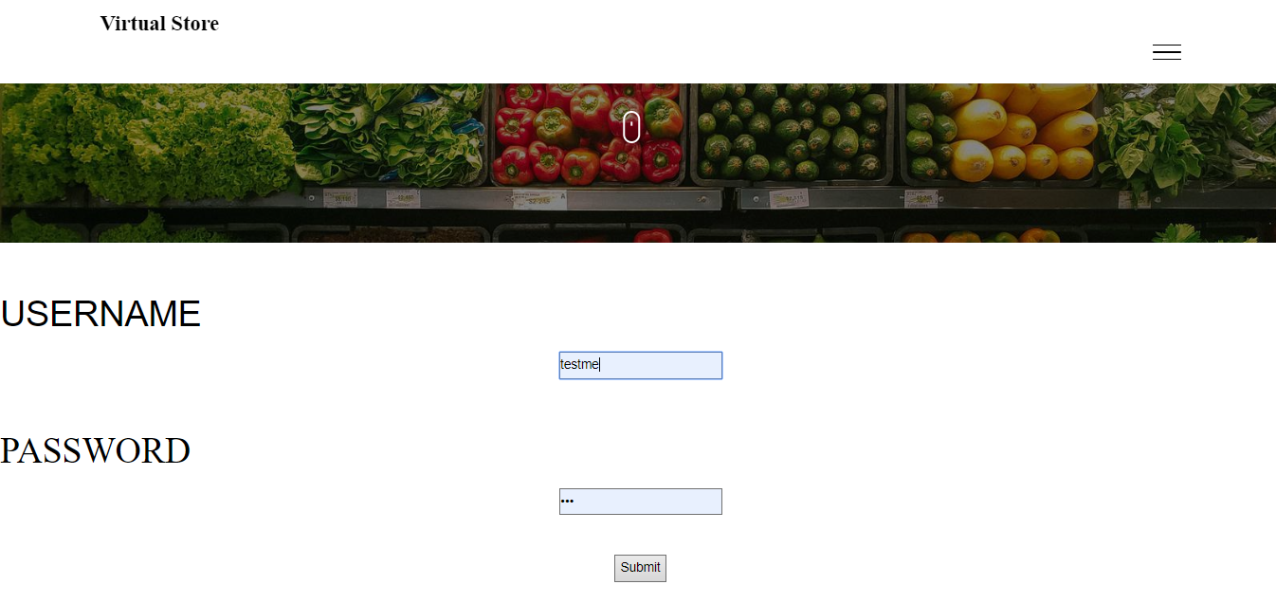

1. **The Login1.php file will run on submit click and it will check if username and password matches customername and phone in customer table in database. If it matches then the page will redirect you to products page**

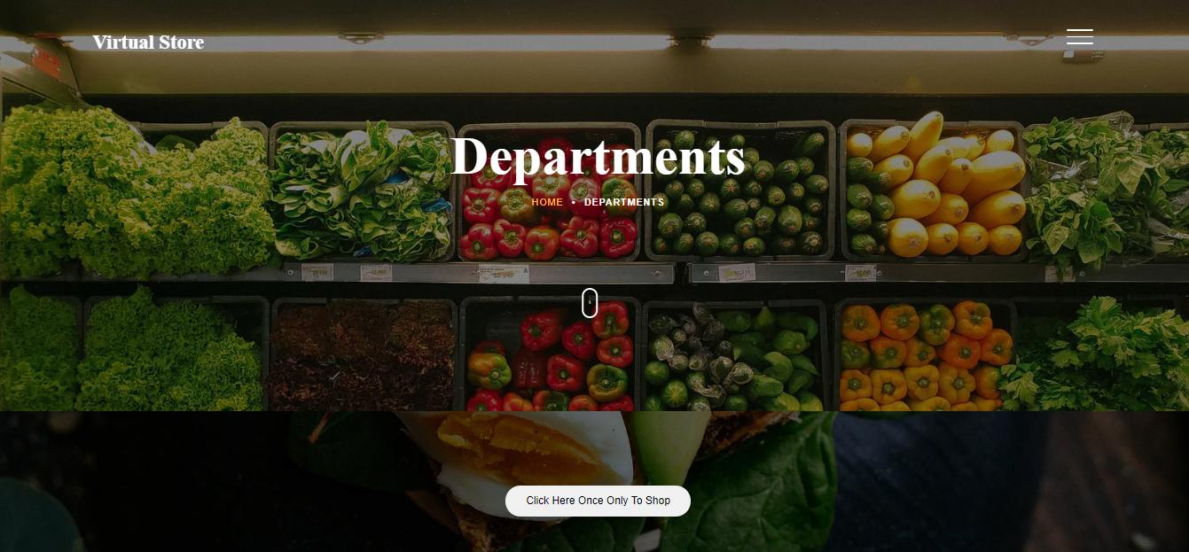

1. **You are on restaurant.html file now which is departments and product page. Click on “Click here once only to shop” which will run addorder.php file.**

**The addorder.php file insert the data in orders table of database. It takes customerid which was entered earlier and stored in isset($_SESSION['user'] and ordered from sequence oid in database. After the insertion the ordered which has been created against customer will be saved in isset($_SESSION['orderid']**

**NOTE THAT THIS BUTTON SHOULD BE ONLY CLICKED ONCE FOR 1 SESSION OF SHOPPING. IF USER WANT TO DO NEW SHOPPING AFTER LOGGING OUT AND LOGGING IN THEN ONLY THIS SHOULD BE PRESSED.**

**IT BASICALLY CREATES ORDER ID. SO CLICK IT ONCE ONLY.**

**AFTER LOGGING OUT AND LOGGING IN BACK AGAIN CLICK IT BACK.**

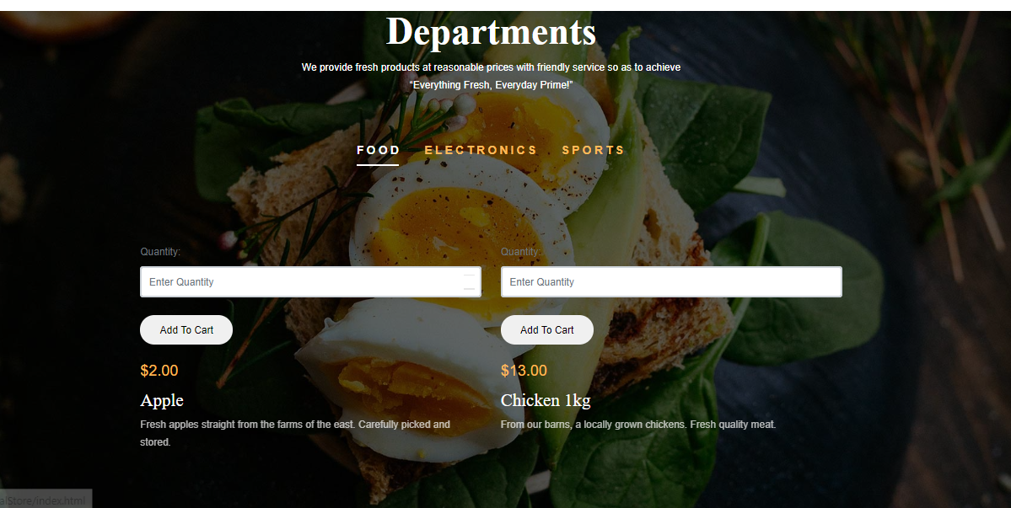

1. **There are 3 departments from choose from. You can click anyone at any time. Put quantity and click add to cart. You can click add to cart for same item any number of times. By clicking add to cart for apple code will go to apple.php where in data will be inserted in orderitem table in database. The customerid and orderid is taken from the session that we have stored earlier.**

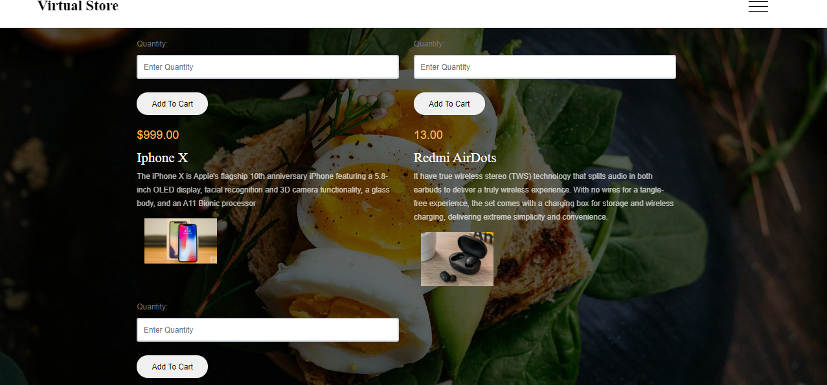

1. **You can switch between tabs. And Add items to cart. Each item has its own php file. Like iphone.php, airdots.php etc. These php files insert record in database**

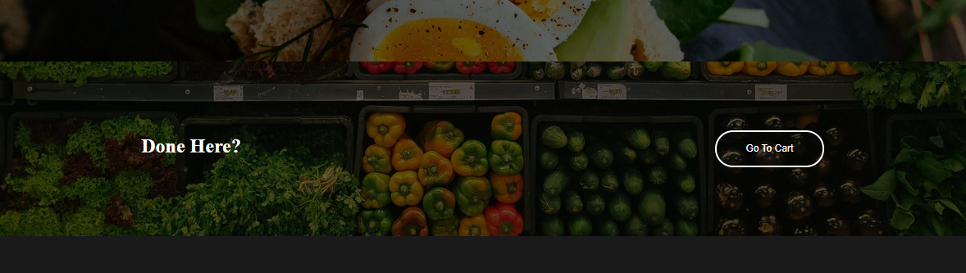

1. **After done shopping got down and click go to cart. It will redirect you to trylist.php and cart will open**

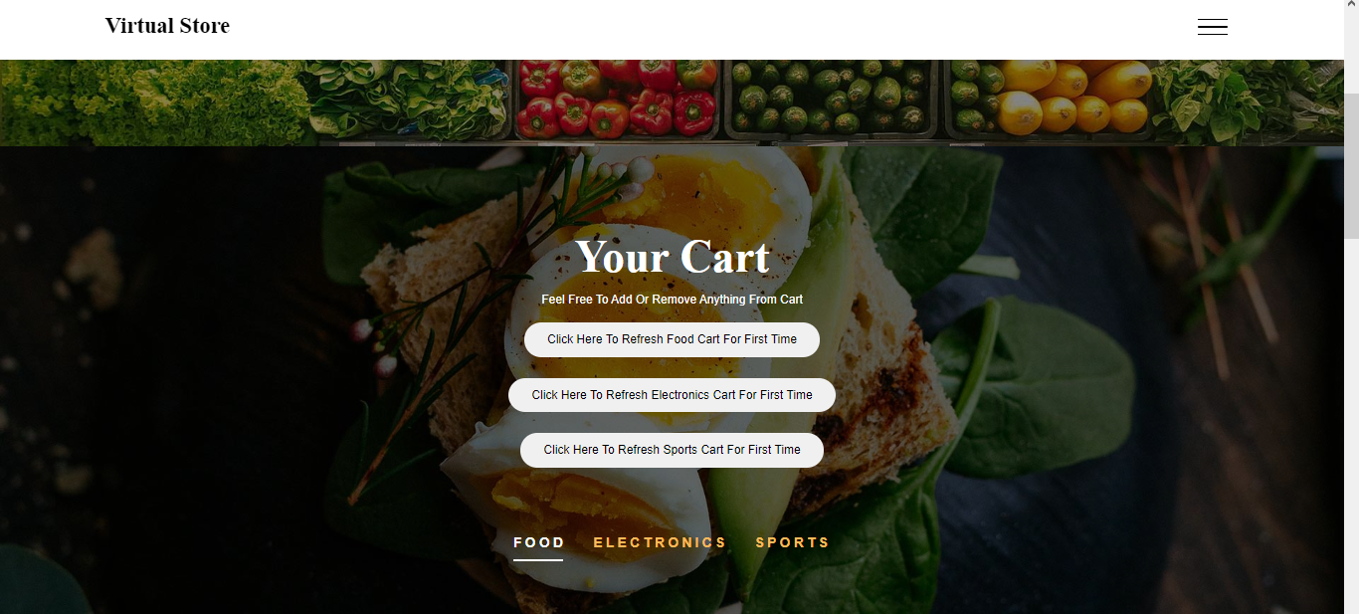

1. **Click each of these once only. Code for foodcalculate.php, sportcalculate.php and electronicscalculate.php will run and the items in cart of FOOD, ELECTRONICS AND SPORTS will be refreshed and new data will be shown.**

**Basically all 3 of these php files insert data in foodqt table in database where**

$sql='SELECT sum(od.quantity) '.

'from product p, orderitem od, orders o, customers cw '.

'where o.customerid=cw.customerid AND od.orderid=o.orderid AND od.productid=p.productid AND cw.customerid= :nums AND o.orderid= :qa AND p.productid = 10';

This query takes out some and outs in foodqt table like

$strSQL = 'INSERT INTO foodqt(PRODUCTID,ORDERID,TOTALQUANTITY,UNITPRICE) '.

'VALUES(10,:tew,:cals,13.00)';

For each of the item.

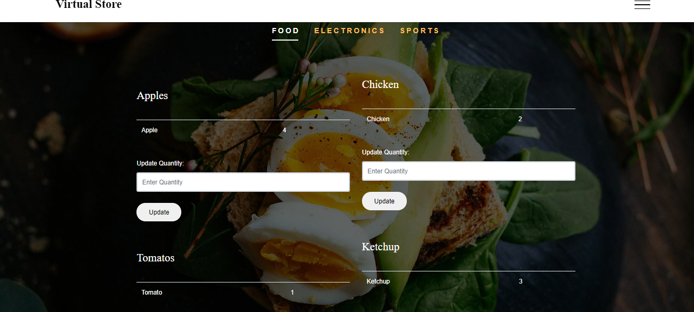

1. **Data of all elements will be displayed by use of select statement in trylist.php file.**

**You can update the cart by adding more or less value and clicking update.**

**The update button will run removeapple.php or removeanyelement.php code. Which will update the quantity in foodqt table.**

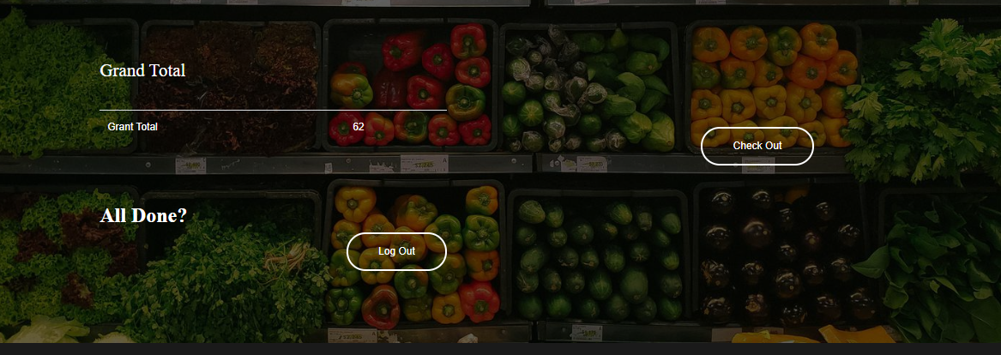

1. **By doing down you can see the grand total which is always updated when you change any element of product in your cart.**

**You can click check out which will redirect you to same page as there is no billing here**

**Click log out and it will run logouthere.php**

**What this does is the it put values of**

**isset($_SESSION['user'] to ZERO**

**and**

**isset($_SESSION['orderid'] to ZERO**

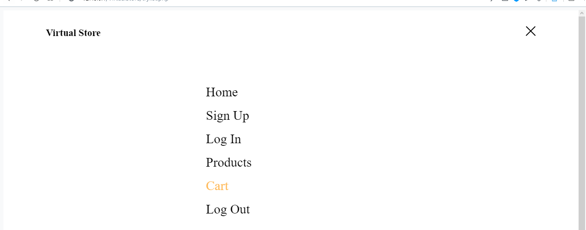

1. **You can always side bar menu to go to any page anytime. Try to log out of session after shopping.**

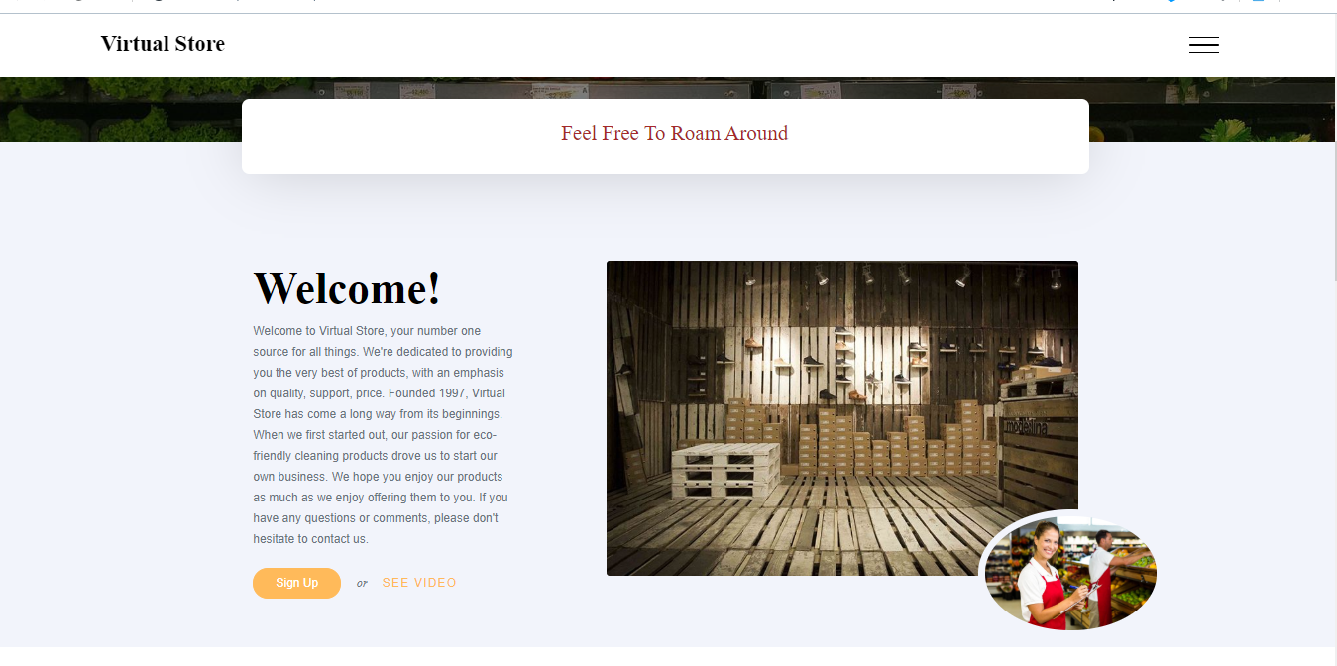

1. **Index.html is the home page where you can find useful information about the virtual store company**

**THIS IS IT!**